FTF FY 2023 Performance Scorecard USAID Kenya

This Feed the Future (FTF) Performance Scorecard assesses the USAID Kenya progress toward FY 2030 Performance Targets.

# Performance Overview



The FY 2023 **On track** value is determined by drawing a line from the baseline (FY 2022) to the FY 2030 Target. For FY 2023, Performance Targets are considered **On track** if they have reported at least 90% of that value.

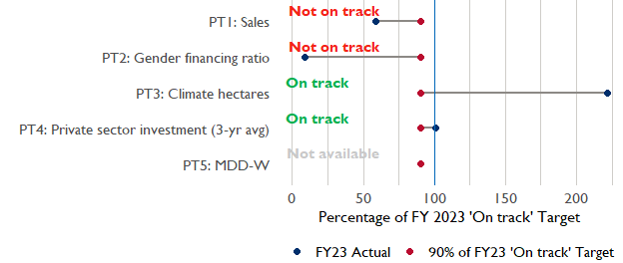

**Note:** *For Performance Target 2 (Gender financing ratio), the target is to increase financing to females for those OUs that are already achieving parity ($1).*

*For Performance Target 4 (PSI), all targets are relative to the last three years’ reporting. In future years, the interim targets may increase.*

*For Performance Target 5 (MDD-W), all FY23 actual values are also the baseline, and may have been collected in a prior year. See the detail page for more information.*

*See detailed* [*methodology document*](https://docs.google.com/document/d/13n-43ppFiGKauscQ7HaAiQDCM4DssGEgRdq2fMyTDn0/edit) *here. If you have questions, please email the FTF Data and Analytics team at* [refs.adl.da@usaid.gov](mailto:refs.adl.da@usaid.gov).

### Performance Target (PT) Details

This section shows PT scores for each applicable PT for USAID Kenya.

## Performance Target 1: Value of annual sales of producers and firms receiving USG assistance



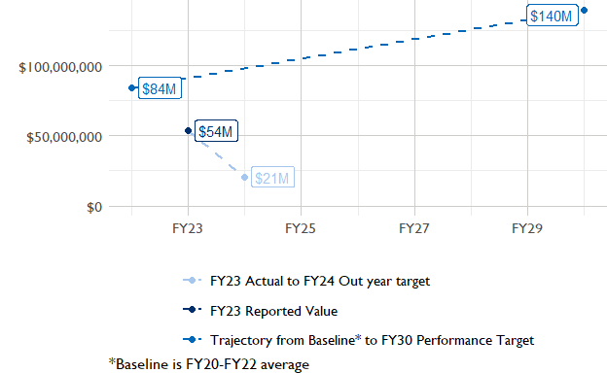

In FY 2023, USAID Kenya had 9 activities that aligned the ‘Value of annual sales from producers and firms receiving USG assistance’ (EG.3.2-26), and 7 contributed to the sales total of $53,590,000.

###### Performance Target 2: Value of financing accessed by female FTF participants per $1 of financing accessed by male FTF participants



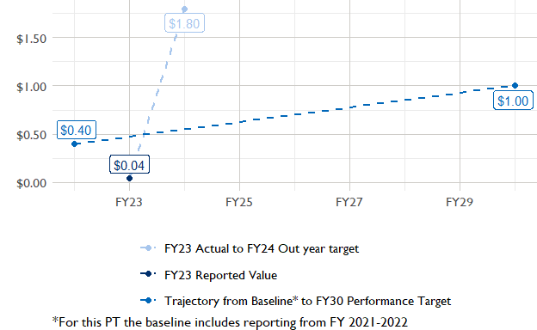

In FY 2023, USAID Kenya had 3 IMs/Activities that reported all four sex disaggregates needed to contribute to PT2. The total value of financing among all activities, regardless of disaggregates, was $55,340,000 (EG.3.2-27 total), with $55,340,000 that was disaggregated by females and males, and an additional $44,500,000 to ‘mixed’ firms that have both males and females, and $0 that was not sex disaggregated.

###### Performance Target 3: Number of cultivated hectares under climate adaptation/climate risk management practices and technologies with USG assistance



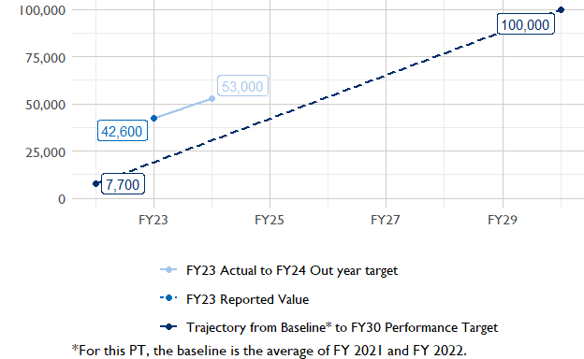

In FY 2023, Kenya had 18 activities that aligned the indicator for hectares under improved management practices (EG.3.2-25). Of those activities, 4 reported on the ‘Climate adaptation/climate risk management’ disaggregate and contributed to the OU total for this PT.

###### Performance Target 4: Value of private sector investment leveraged by the USG to support food security and nutrition



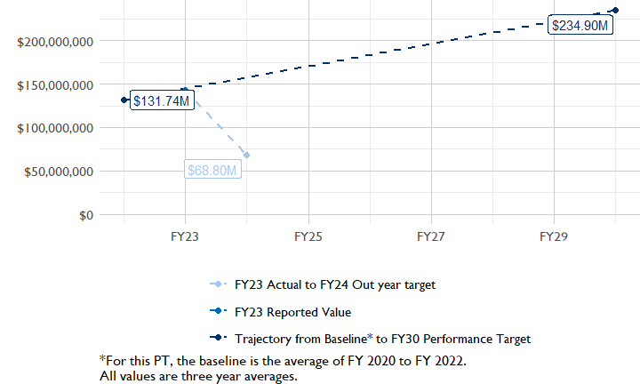

In FY 2023, Kenya had 6 activities that aligned the private sector investment indicator (EG.3.1-15/-14), ‘Value of new private sector investment leveraged by the USG to support food security and nutrition [IM-level]’, and 4 contributed to the OU total in FY 2023.

###### Performance Target 5: Percent of women consuming a diet of minimum diversity (MDD-W)



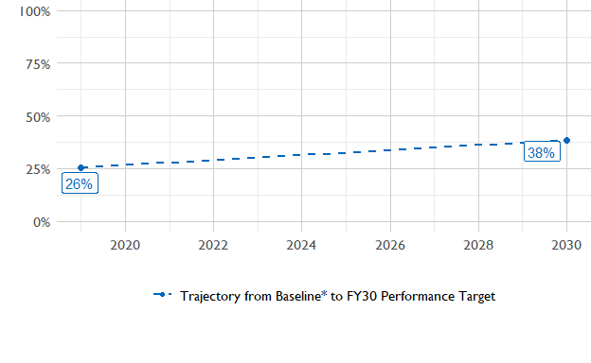

The baseline population-based survey (PBS) for USAID Kenya was in 2019 and showed that 26% of women in the ZOI had access to a minimally-diverse diet. The FY30 target is 38% percent.The most recent PBS was in 2023, but results are not yet available. The following PBS is scheduled for .

### National Context

National level data was collected from the [World Bank’s Open Data portal](https://data.worldbank.org/) that measures key indicators at the national level.

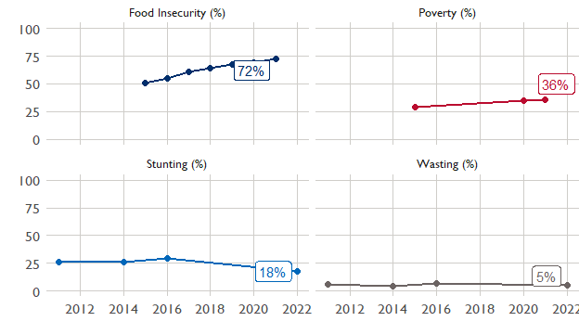

## Agricultural Transformation Index Score

The [IFPRI Agricultural Transformation Index (ATI)](https://agrilinks.org/events/drivers-agrifood-system-transformation-lessons-feed-future-country-studies) Score is a high level indicator of the status of agricultural market systems in each country.

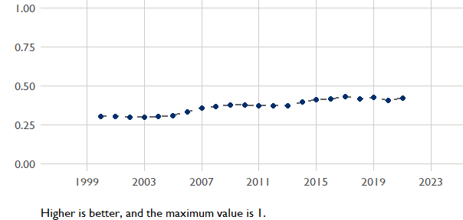

## Budget Trend

At the Operating Unit level, the Performance Targets are based in part on the FY 2024 budget request. The budget chart below includes EG.3 money only.

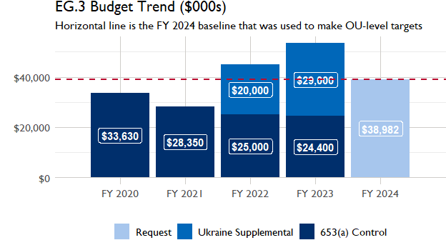

## Active Portfolio

The following activities are considered “active” based on their reporting in FY 2023 and expected FY 2024 reporting. The Analytics, Data and Learning Division defines an “active” activity as one that reported targets, actuals, or deviation narratives for the current year (FY 2023), or the next out year targets (i.e. FY 2024).

## Top Activities (Award Disbursements and Results)

This section highlights some activities in the USAID Kenya (KENYA) portfolio that have the highest level of disbursements and high reporting values for the relevant indicators. The table below shows the top (up to) five activities by the total transaction amount for disbursements. The columns to the right indicate if these activities are reporting on relevant PT indicators.

| Award Number | Activity Code | Activity Name | FY23 Disbursements | PT1 | PT2 | PT3 | PT4 |
| --- | --- | --- | --- | --- | --- | --- | --- |
| AID-615-L-17-00001 | 1392 | Kenya Feed the Future Livestock Market Systems | $8,202,119 | X | X | X | X |
| AID-615-A-17-00006 | 1397 | Kenya Feed the Future Crops and Dairy Market Systems Development Activity | $8,091,579 | X | - | X | X |
| 7200AA21C00056 | 5924 | USAID Africa Trade and Investment Program (ATI) | $3,921,408 | X | - | - | X |
| 72061519CA00002 | 2250 | Scaling the Impacts of USAID Resilience Programming through Local Systems (SILS) | $3,183,388 | - | X | - | X |
| 72061518C00004 | 1394 | Kenya Investment Mechanism | $2,530,998 | - | X | - | X |

**The next table (below) shows the top reporting activities.**

| Award Number | Activity Code | Activity Name | Total Disbursements | Sales | Hectares | PSI |
| --- | --- | --- | --- | --- | --- | --- |
| AID-615-L-17-00001 | 1392 | Kenya Feed the Future Livestock Market Systems | $8,202,119 | $22,804,754 | 115 | $0 |
| AID-615-A-17-00006 | 1397 | Kenya Feed the Future Crops and Dairy Market Systems Development Activity | $8,091,579 | $21,560,481 | 4 791 | NA |
| 72DFFP19CA00003 | 1373 | 109255: FFP - Nutrition in ASALs Within Integrated Resilience Institutions (NAWIRI) - Mercy Corps | NA | $4,993,095 | 37 649 | NA |
| 7200AA21C00056 | 5924 | USAID Africa Trade and Investment Program (ATI) | $3,921,408 | $2,954,551 | NA | $4,674,614 |
| 72061522FA00009 | 4859 | USAID KENYA - SOLAI CONSERVATION AGRICULTURE EXTENSION (SCALE) PROGRAM | NA | $796,152 | NA | NA |

### Appendix 1: Response to “Not on track” Performance Targets

This section provides space for USAID Kenya to provide an explanation of why the following PTs are not on track and how you could adjust to be on track in the coming year(s). To help in your response(s), the relevant section of the FTF/GFS Key Issue Narrative (KIN) is provided, as it *may be* useful in drafting a responses. Note that the KIN is addressing the sum of the out year targets (FY 2023) set by the USAID Kenya activities that are reporting on each PT. The FY 2023 out year targets were set prior to the establishment of the FY 2030 Performance Targets, so the below explanations from the KIN may not apply to the Performance Target deviation.

* In Section 4 of the FTF KIN, your OU discusses FY24 and FY25 targets, while these Scorecards are addressing progress against a trajectory from historical reporting to your OU’s FY30 target.  Also, the FY 2023 out year targets were set prior to the establishment of the FY 2030 Performance Targets.  Therefore, the below explanations from the KIN may not apply to these FY30 Performance Target deviations.
* These responses will be used to compile a Congressional report, the GFSS Implementation Report, to discuss progress against the FTF FY 2030 Performance Targets, as mandated by the GAO.
* Only PTs that are ‘Not on Track’ require review and explanation from the OU.

## Performance Target 1: Sales

*Excerpt from FY23 KIN Section 4 to consider:*target was exceeded by 71% The target was exceeded because the KCDMS and LMS activities, both expected to end in 2022, were extended after the Mission received Ukraine Supplemental funding. KCDMS exceeded its target by US$ 8 million due to the implementation of a farmer Loyalty program (offering discounts to farmers for bulk and repeat purchases) and well-executed radio campaigns and field days, which increased the visibility and popularity of agro-dealers. This heightened market presence effectively drew many buyers seeking fertilizers and, subsequently, led them to purchase additional agricultural inputs from the agro-dealers. The LMS activity exceeded its target for sales by 40 million. The results for FY 2023 are significantly lower than the results for FY 2022 (US$ 105,406,571) because of significantly scaled back budgets and a technical shift for both LMS and KCDMS which had to implement Ukraine Supplemental funding to mitigate the impacts of the global food crisis. KCDMS focused on providing fertilizers to farmers, soil testing and poultry. KCDMS closed in October 2023 resulting in a further drop in targets for 2024. LMS is focused on sustaining operations of the markets and market-based supply of food and will close in mid 2024. New activities have been designed and will begin reporting on this indicator in 2025, because 2024 will mostly be a mobilization year as the activities start ramping up results in 2025.

#### Enter USAID Kenya (KENYA) Response Below:

## Performance Target 2: Gender financing ratio

*Excerpt from FY23 KIN Section 4 to consider:* target was exceeded by 12% The target was exceeded because the USAID Kuza activity which had initially planned to enable two financial institutions to access $ 2.3 million in finance, was able to provide $ 4.9 million to 6,317 individuals,$ 2.7 million of which went to women. KUZA, through the Impact for Northern Kenya (INK) fund, lends money to financial institutions for onward lending to individual clients raising significant capital. Initially, KUZA was not aware that it could count individual clients of the financial institutions receiving money from the INK fund, however a clarification from the Mission enabled them to count these numbers, thus the significant increase in the number of clients reported as accessing finance. LMS linked cooperatives with financial institutions, enabling them to gain access to additional funds for lending, expanding their lending capacity (customer base). Consequently, Micro, Small and Medium Enterprises (SMEs) in Northern Kenya that face obstacles in obtaining finance from banks such as lack of collateral and other stringent bank requirements, were able to secure loans, surpassing the planned target. LMS linked women-based village savings and loans groups to the cooperatives, enabling more women than anticipated to access finance. KIM, which was the flagship mechanism reporting to this indicator, came to an end in 2023. LMS is coming to an end in 2024. KUZA will continue reporting against this indicator and is driving the target for next year. The FTF PSA and the FTF LFSare both currently in procurement and are expected to report against this indicator in the coming years.

#### Enter USAID Kenya (KENYA) Response Below: